Biography- Prof. Lioz Etgar

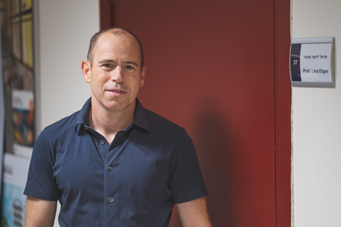

Prof. Etgar earned his master’s degree and continued on a direct track to a PhD at the Technion: He was part of the Excellence Program of Nanoscience and Nanotechnology, concentrating on fundamental properties of QDs (and received the Wolf Prize for excellent PhD students).

In his postdoc research, he joined Prof. Michael Graetzel’s group at EPFL on a Marie Curie post-doctoral fellowship, where he acquired top-tier expertise with solar cells and their mechanisms. In the fall of 2012, he joined the Institute of Chemistry at the Hebrew University of Jerusalem (HUJI) as a senior lecturer.

He established a globally recognized excitonic solar cell research team. Since joining HUJI, He has published more than 130 papers, including papers in PNAS, JACS, Advanced Materials, Energy & Environmental Science, Nano Letters, and more, and have delivered more than 60 invited talks at international conferences.

His main research field is related to perovskite, starting from its synthesis, characterization (optical and physical) and its use in optoelectronic devices such as solar cells and LEDs. In the perovskite field, He was the first to demonstrate the simultaneous use of CH3NH3PbI3 perovskite as a light harvester and a hole conductor in a solar cell. These findings were published in 2012 in JACS, with more than 2600 citations to date. This poineering work was highlighted in: CHEMISTRY TOP TEN: THE "LIGHT" SIDE OF LEAD; *http://sciencewatch.com/articles/chemistry-top-ten-light-side-lead*, written by Dr. John Emsley from the Department of Chemistry, Cambridge University, UK.

On 2016he received the prestigious Krill Prize, which was bestowed by the Wolf Foundation, and was ranked as Associate Professor in 2017. Prof. Etgar has established a top-flight research group which is one of the leading research groups in the PV field – and in particular in the perovskite area.

In addition to his academic career, Prof. Etgar has founded SOLRA PV a startups company based on his perovskite inventions, focusing on Indoor PV for IOT applications.