Deep Jariwala-Short Bio
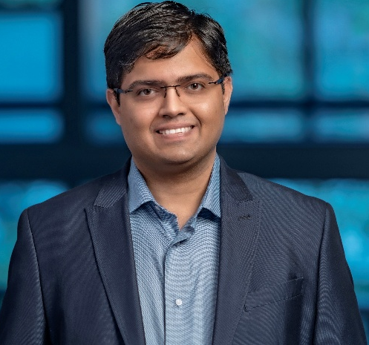
Deep Jariwala is an Associate Professor and the Peter & Susanne Armstrong Distinguished Scholar in the Electrical and Systems Engineering as well as Materials Science and Engineering at the University of Pennsylvania (Penn). Deep completed his undergraduate degree in Metallurgical Engineering from the Indian Institute of Technology in Varanasi and his Ph.D. in Materials Science and Engineering at Northwestern University. Deep was a Resnick Prize Postdoctoral Fellow at Caltech before joining Penn to start his own research group. His research interests broadly lie at the intersection of new materials, surface science and solid-state devices for computing, opto-electronics and energy harvesting applications in addition to the development of correlated and functional imaging techniques. Deep’s research has been widely recognized with several awards from professional societies, funding bodies, industries as well as private foundations, the most notable ones being the Optica Adolph Lomb Medal, the Bell Labs Prize, the AVS Peter Mark Memorial Award, IEEE Photonics Society Young Investigator Award, IEEE Nanotechnology Council Young Investigator Award, IUPAP Early Career Scientist Prize in Semiconductors, the SPIE Early career achievement award and the Alfred P. Sloan Fellowship. He has published over 150 journal papers with more than 25000 citations and holds several patents. He serves as the Associate Editor for Nano Letters (ACS) and has been appointed as a Distinguished Lecturer for the IEEE Nanotechnology Council for 2025 as well as Fellow of Optica (2026). He is the co-founder of Agni Semiconductor, a start-up company aiming to commercialize the ferroelectric memory technology.
Website: jariwala.seas.upenn.edu
Email: dmj@seas.upenn.edu

